# Task 1:

1. Connecting to API to extract the data to system

2. Extracted data to be stored on S3

3. Consider it as application which involves : development, deployment, monitoring.

# Requirements:

* API Gateway
* JSON file with sample data
* AWS lambda
* S3 Bucket

# Architecture:

Postman – API Post –API Gateway – Trigger AWS Lambda – Stores data in –S3—Cloud watch

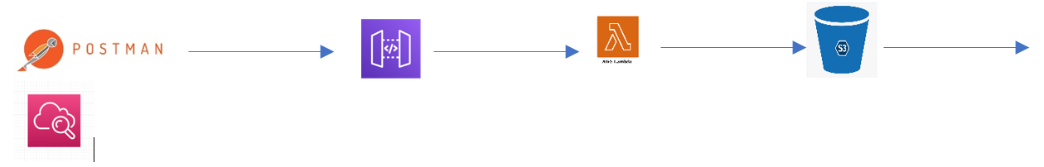

  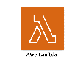  

# Logic Implemented:

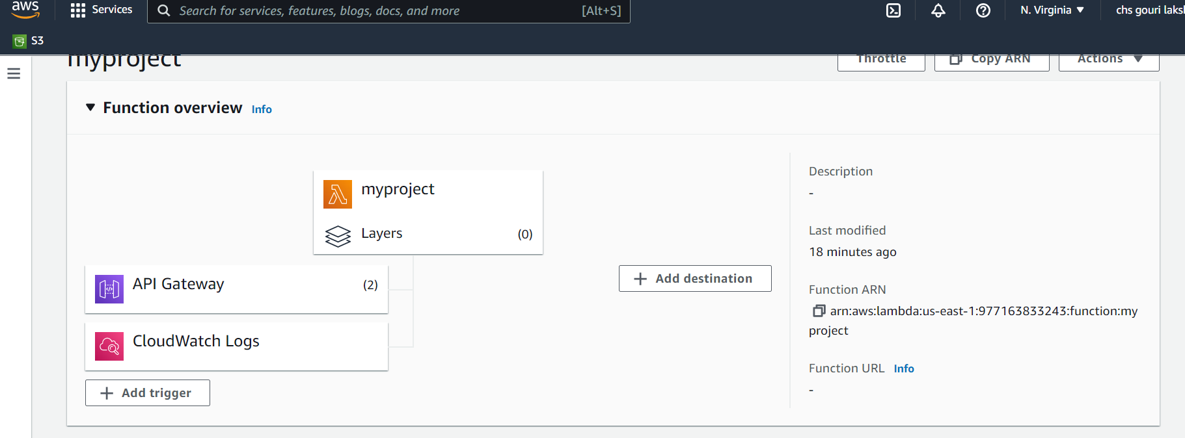

1. Creation of IAM role which requires Lambda basic access and S3 full access.

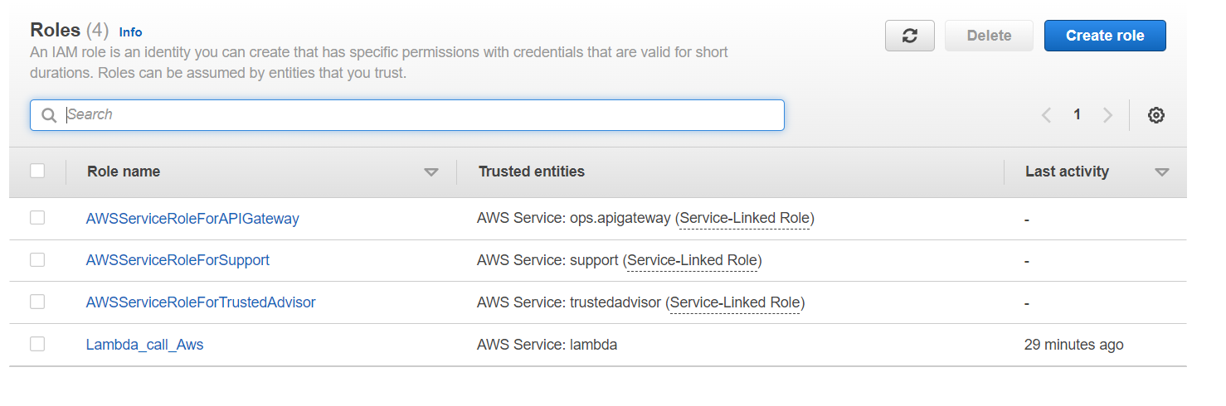

2. Create API Gateway that integrates with Aws Lambda functions

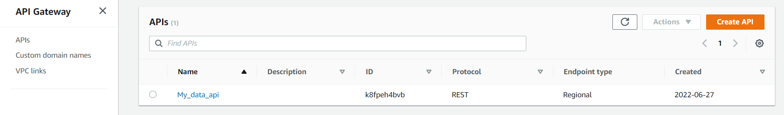

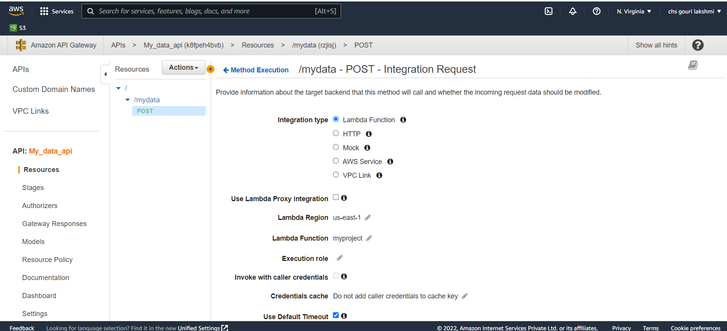

2. Create S3 bucket

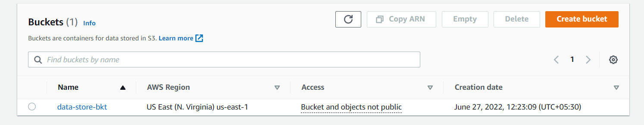

2. Create a function in AWS Lambda and attach the role that we have created.

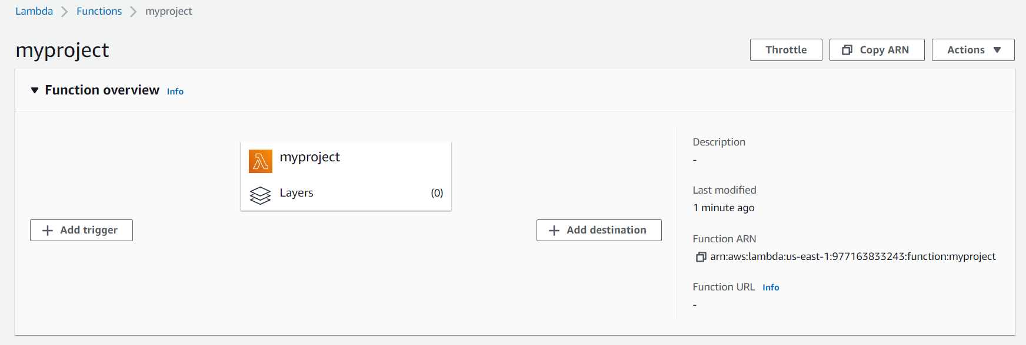

Code Developed: 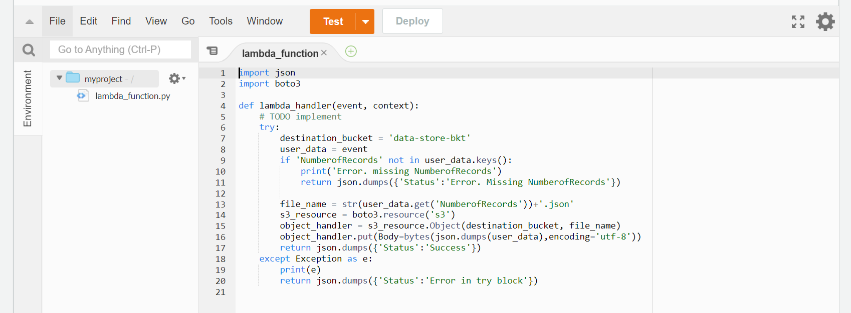

After deploying the code the files got stored in:

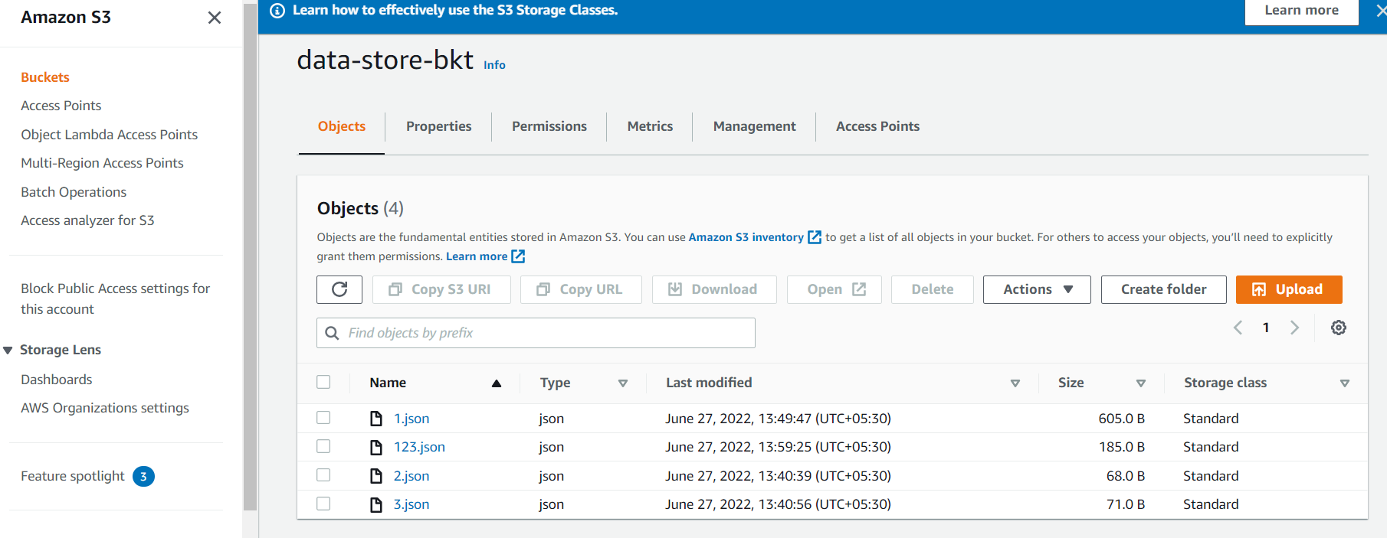

# Monitoring:

I have created clod watch log group for monitoring of the application logs.

And then attached log group to the Lambda function.

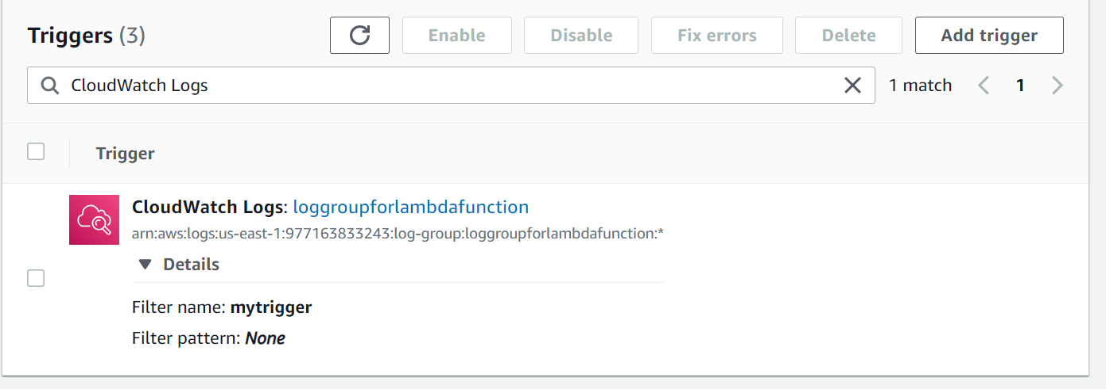

Sample data I have taken:

{

"NumberofRecords": "123",

"person1": [

{

"first": "Nicole",

"last": "Adelstein"

}

],

"person2": [

{

"first": "Pleuni",

"last": "Pennings"

}

],

"person3": [

{

"first": "Rori",

"last": "Rohlfs"

}

]

}

